- @PostConstruct
  - It runs the method (which is being annotated with it) just after the bean is created.
  - init() method also does the same, but it was there in legacy XML config.
  - 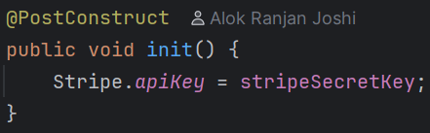
here, the method name can be anything, it is not bounded with init(), only the @PostConstruct matters here.

- Payment Integration Flow
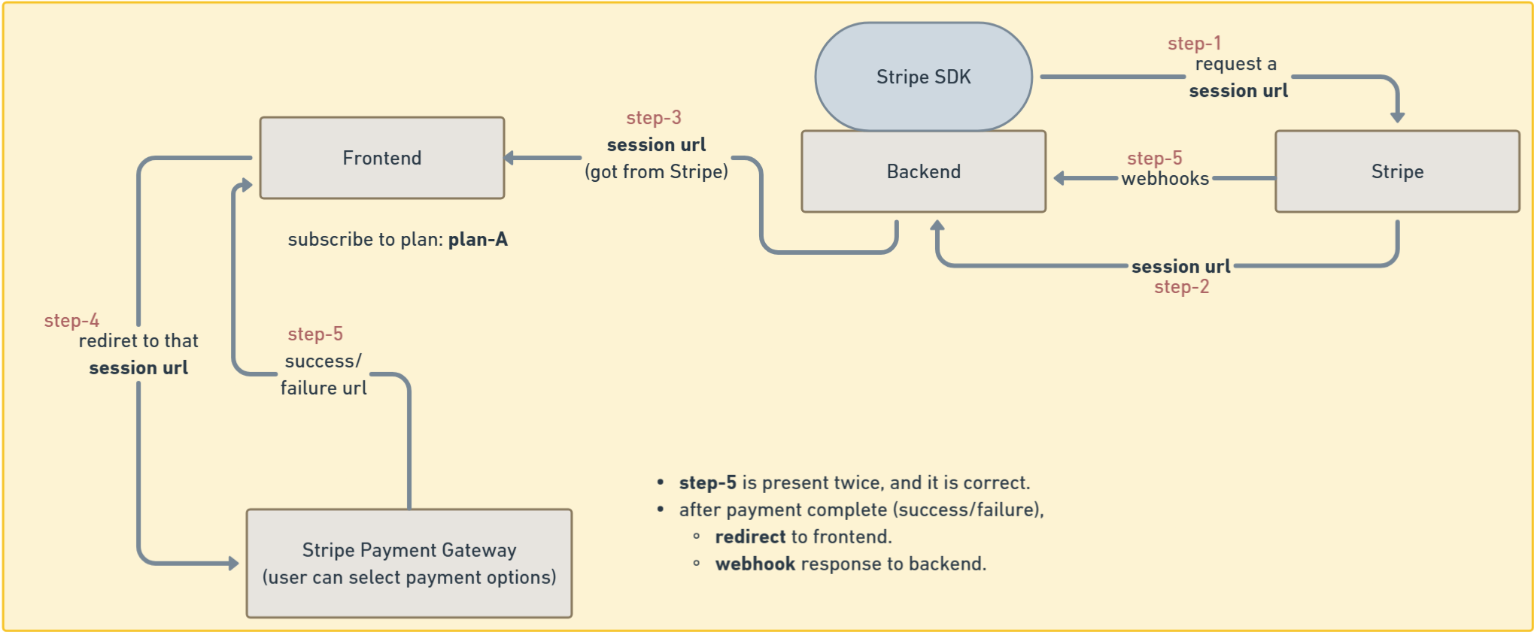
- Why redirect to frontend and webhook for backend exists?
  - Redirect is to make the user know about the status, like success or failure.
But user can fake it by manually typing the url and will get a free subscription if webhook doesn’t exist.
  - Webhook on the other hand, sends response to the backend about the status of payment, backend will verify it and stores in the database.
- There is a keyword called volatile in Java.
  - (Stripe class)
  - volatile make sure that if one thread changes the variable, then other thread will immediately sees that.
  - When you use volatile, all the thread will reference to variable present in main memory directly, not from the thread local cache.
- For stripe, you need to set the API key with Stripe class. [Stripe related]
  - You will set that apiKey variable.
  - 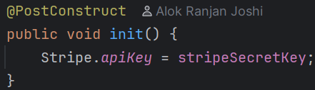

- As we need subscription based payment, like pro plan, normal plan etc, we need to create product in stripe dashboard. [Stripe related]
  - 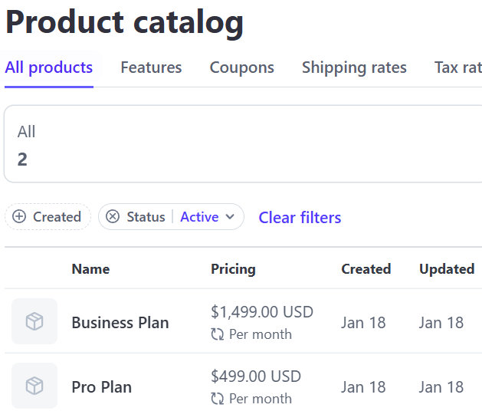
- Now you need to make the entity for Plan as well. [Stripe Related]
  - 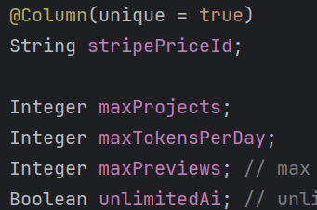
  - That stripePriceId is there inside the stripe dashboard.
  - Its not the Product_id, its Price_id (both are different in Stripe Dashboard)
  - And these should be directly appended by database, or you can create a REST end point that can only be accessed by the authorized people.
  - One product (in our case Plan) should have same price, why there can be multiple prices under a single product in Stripe?
    - 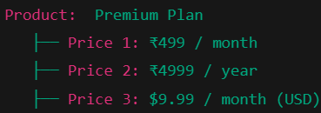 (you can think like this)
  - One product_id can have multiple price_id.
  - https://docs.stripe.com/billing/quickstart here you can checkout the Stripe integration docs.
Creating Checkout Session URL
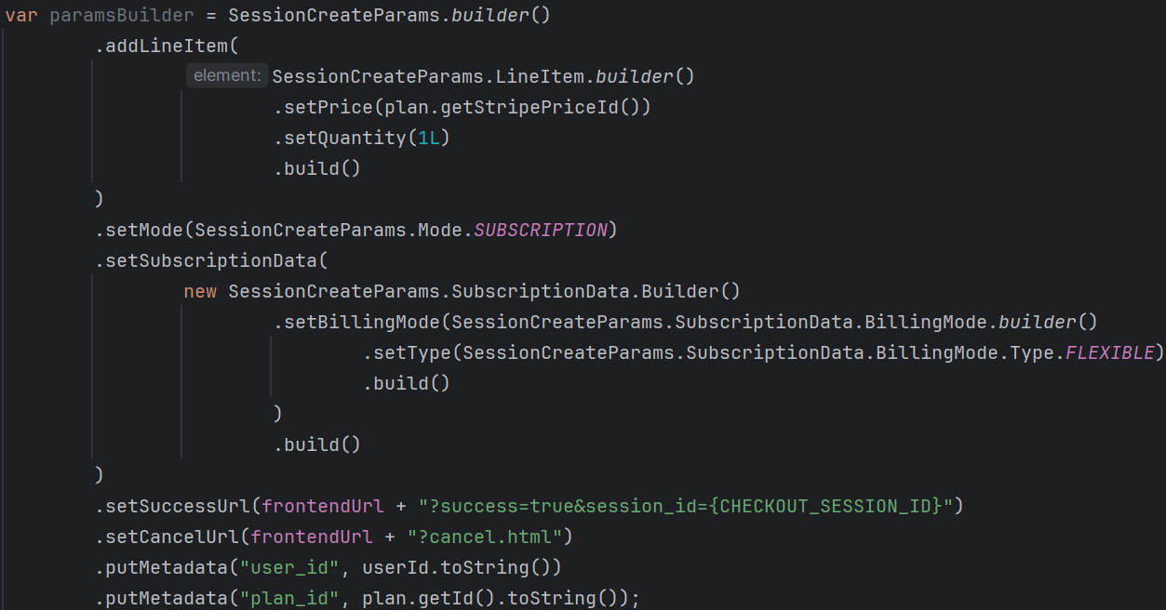
  - Creates a Stripe Checkout Session to start a payment flow
  - Adds one line item using a specific Stripe Price ID (not product) [ addLineItem ]
  - Sets the purchase type as a recurring subscription [ setMode ]
    - Ensures Stripe handles automatic recurring billing
  - Uses flexible billing mode to allow future plan changes (upgrade/downgrade, proration) [ setSubscriptionData ]
  - Redirects the user to a Stripe-hosted checkout page
    - On successful payment, redirects back to the frontend with the Checkout Session ID [ setSuccessUrl ]
    - On cancellation, redirects the user back to the frontend cancel page [ setCancelUrl ]
  - Attaches metadatas [ putMetadata ]
    - Attaches internal user ID as metadata for payment tracking
    - Attaches internal plan ID as metadata to identify which plan was purchased
    - Allows backend to later verify payment and subscription via webhooks
  - Keeps payment handling PCI-compliant by using Stripe Checkout.
  - Here I am creating a session builder, not session; if you see, I have not called the build() method at the end.
  - 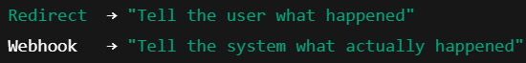
- After that you need to create session
  - This Session.create(…) method makes an API call to stripe and get a session object.
  - This session object contains the url that needs to be sent to the frontend.
- One catch is there here:
  - Even if the same user is doing payment, then also inside Stripe, multiple customers will be created, because Stripe doesn’t know about our customers.
  - 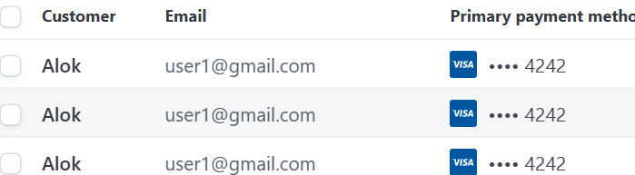
  - Same gmail id (same user), but different customers got created inside Stripe.
- Now to make the Stripe knows if the user is same or not, you need to do the below.
  - 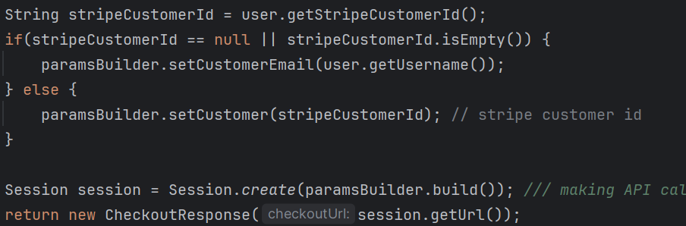
  - Now you can see, the email is fixed (if the user is already present), & you cannot edit the email id in Stripe payment page.
    - 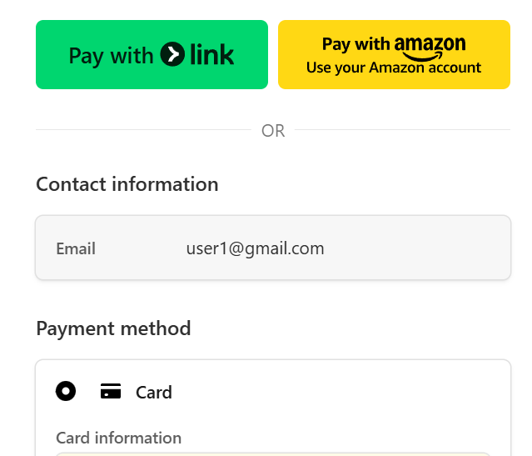
  - But in database we don’t have the customer id present; this will be handled in webhook event handling.
- There are multiple events get triggered
  - 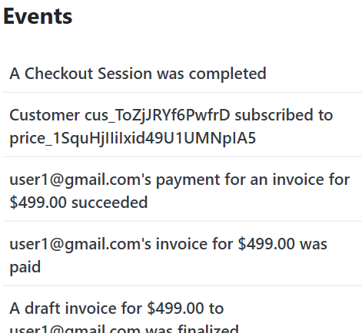
  - Here you can see the customer id and stripe id present (top 2nd event)
  - So, you need to create a webhook that listens to this event and you’ll get the customer id.
  - And also, one webhook to see the payment status (success/failure)
- [[
Now Frontend will get this checkout session URL;
Then Frontend will redirect to that URL;
Then after payment completion, Stripe will respond back to the Redirect URL to frontend & trigger Webhook to send response to the backend.
--- so we need to create the webhooks now ----
]]
- Stripe docs for java: https://docs.stripe.com/api/errors?lang=java
- F
- F
- F
- F

Webhooks
- As our backend is running on localhost, Stripe won’t be able to send the webhook response to our backend, so we need something to listen to those and forward to localhost.
  - Stripe CLI does this. You need to configure this.
  - Stripe CLI docs: https://docs.stripe.com/stripe-cli/use-cli
  - 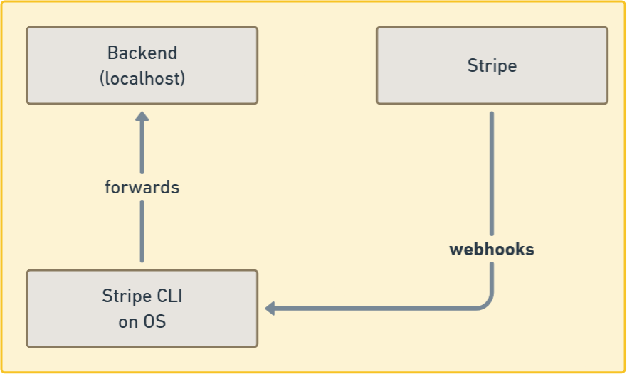
  - When you run the stripe listen command in CLI, you’ll get a secret called webhook signing secret
- We discussed about redirect and webhooks, but still webhooks is not completely secure.
  - Because the webhook endpoint of the backend is a public url, and anyone can send request to that leading to get a free subscription.
  - So, stripe sends a webhook signing secret which is being validated at the backend that the request is coming from the Stripe or not.

- You can see in the inspector in the Stripe dashboard page about all the events that was triggered.
  - 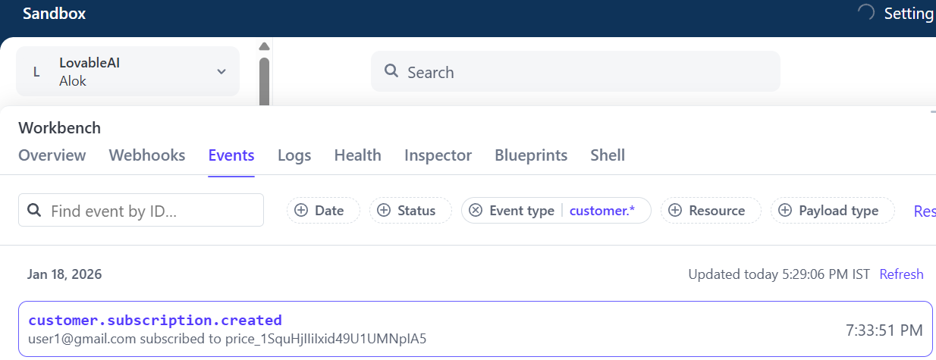
- Create an end-point to listen the Stripe webhook.
  - It’ll always be a post end-point.
    - Here you need to give the proper end-point that handle the webhooks.
  - 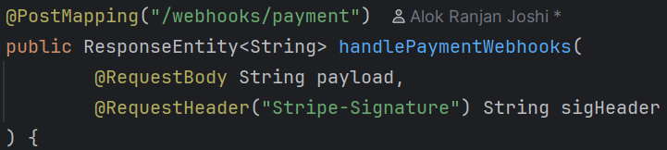
    - Webhook handling controller.
    - The header will be having the key Stripe-Signature, it contains the signature.
  - 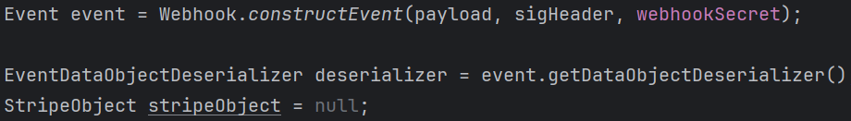
  - 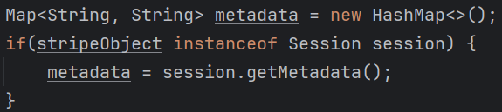

  - Now, when you make payment with the url that you get from the checkout response, you’ll see the logs in the CLI (stripe listen …etc
    - 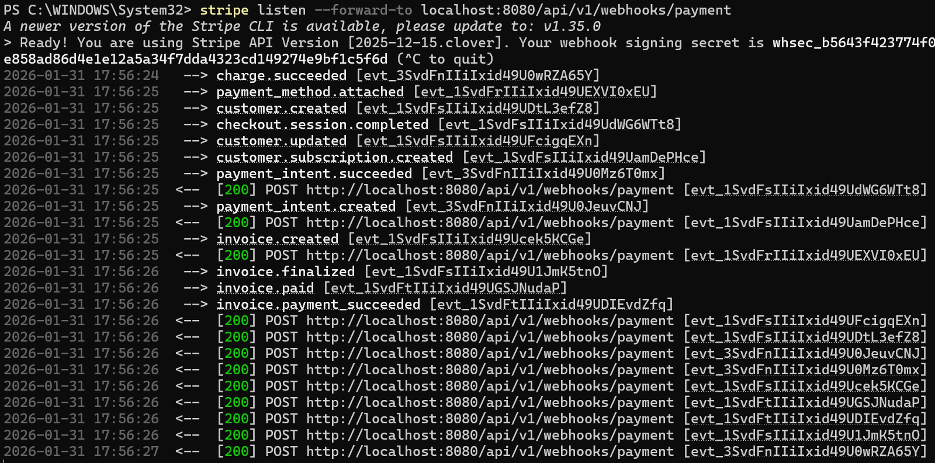
    - These all are events, charge.succeeded, payment_method.attached ….etc etc.
    - And for these events, the webhook event handler endpoint will be triggered once per event. (here you can see all the POST requests)
    - These are the payload and signature header values.
  - 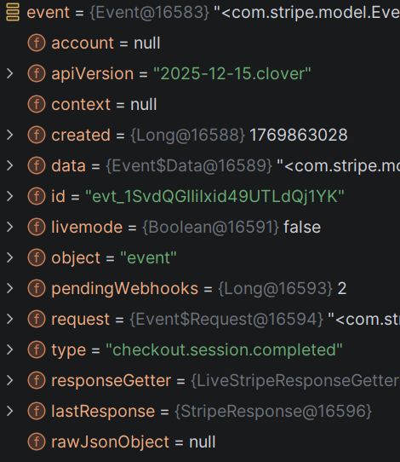
    - This is the event object that was created using the secret key, signature header & payload. You can see event type is also there.
  - After then you you create EventDataObjectDeserializer object using that event object,
    - It contains a key “object” which contains an object of type Session (it extends StripeObject class)
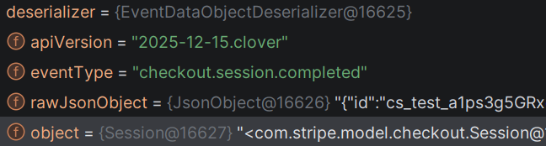
    - That Session object contains all the details like user’s registered email in Stripe, the metadata that was being attached while creating the session (checkout session)
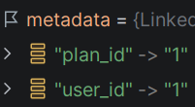

- F

- Events of Webhooks
  - checkout.session.completed [
    - This event occurs only once in our case as it is recurring.
    - User will only go to checkout page once and set the auto-pay kind of thing.
    - Then every interval (month/year) stripe will try to deduct by itself.
  - invoice.paid
    - This event is triggered when the payment is done successfully.
- 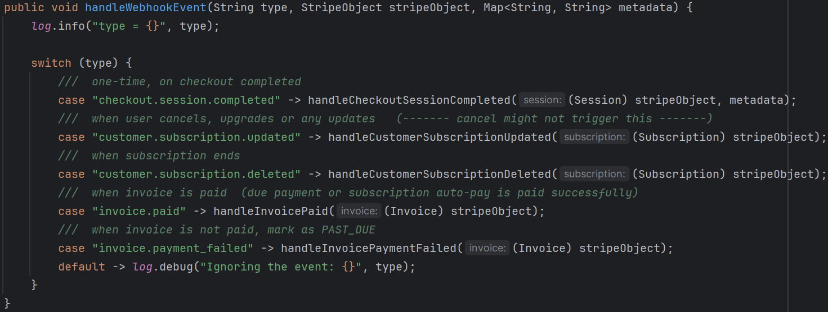
  - This is the webhook handler method where these many events are being handled.
[ check the comments for their purpose ]
  - In Stripe, StripeObject is the parent class of all Stripe objects.

- handleCheckoutSessionCompleted(session, metadata)
  - 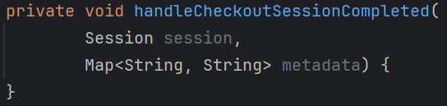
  - On, checkout.session.completed, a new subscription will be created, so here we’ll set the customer id in our database.
    - It contains all like subscription creation, invoice paid, customer updation ..etc.

  - 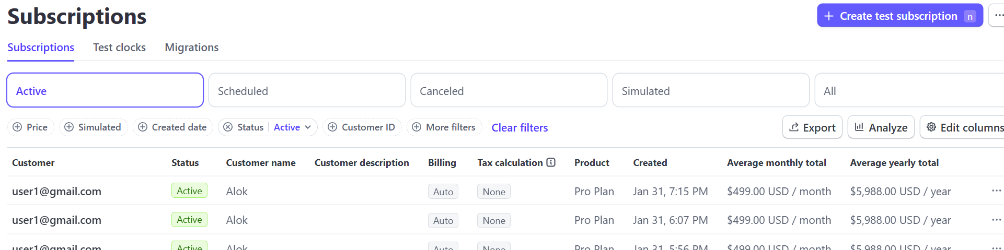
    - These are all the subscriptions.
    - Each subscription is having one unique id.
  - 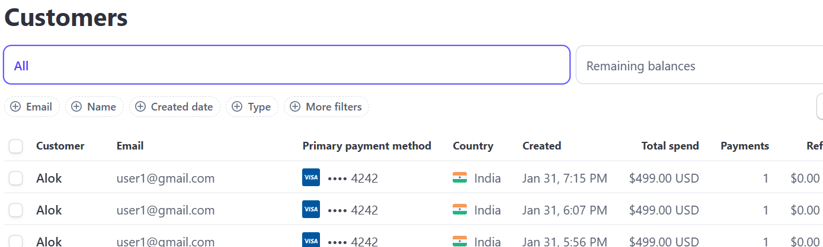
    - These all are customers (redundant till now, because customer id is not stored in DB yet).
    - Each customer is having one unique id.

- F

- F
- 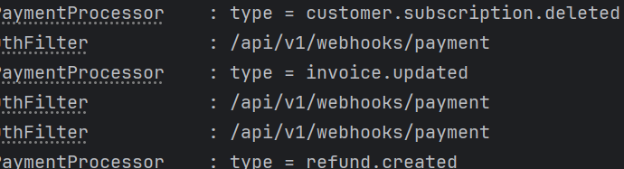
- F
- F
- F
- F
- F
- F

